DOCUMENTATION FOR CAT:

1. **Create database**

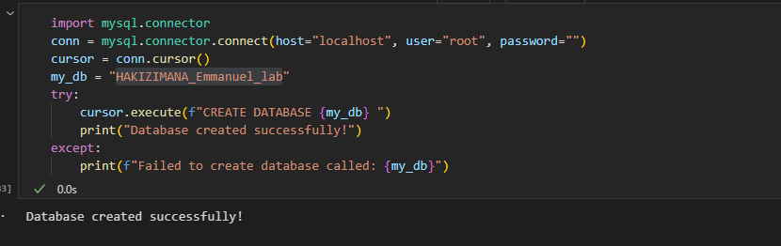

Here , this image illustrate database name by HAKIZIMANA.Emmanue_lab is created.

2**. create tables:**

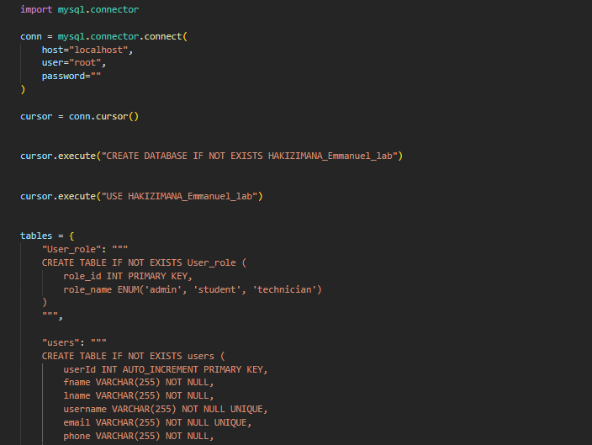

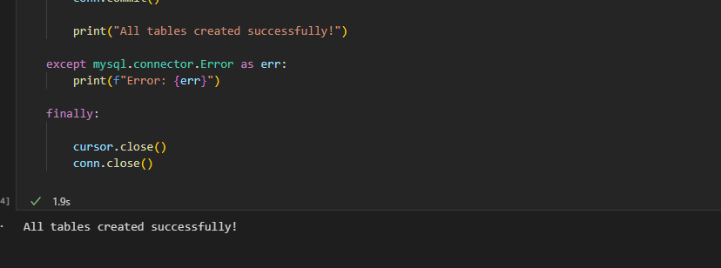

This image is illustrating all table are implemented.

3. **Display tables:**

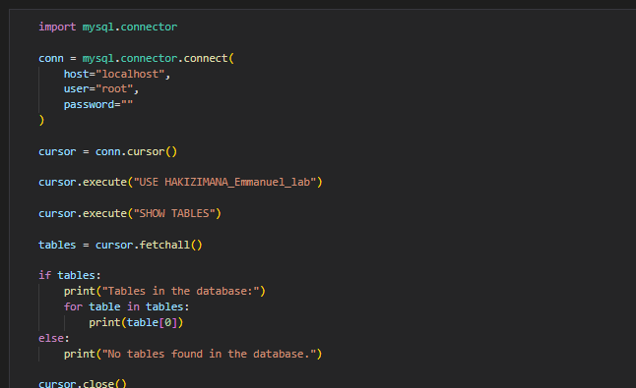

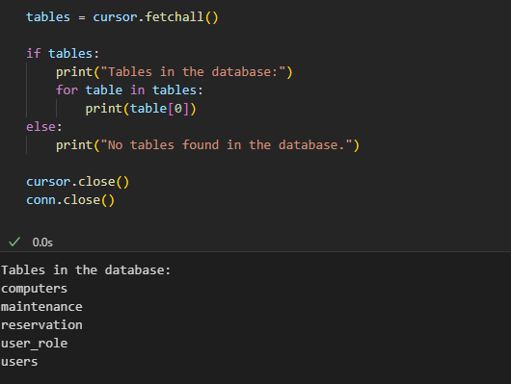

This code is display and select all tables created.

4**.hashed password:**

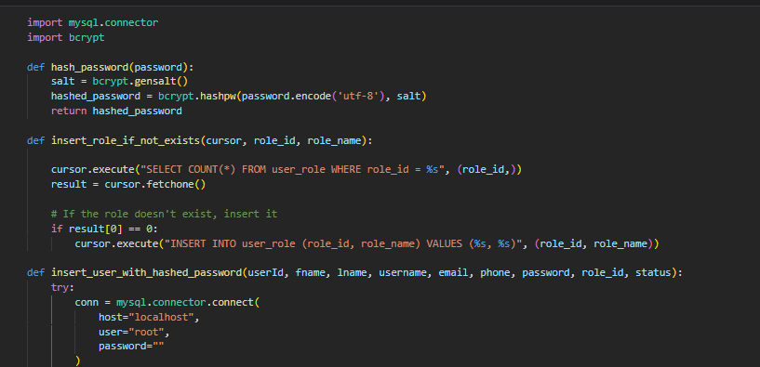

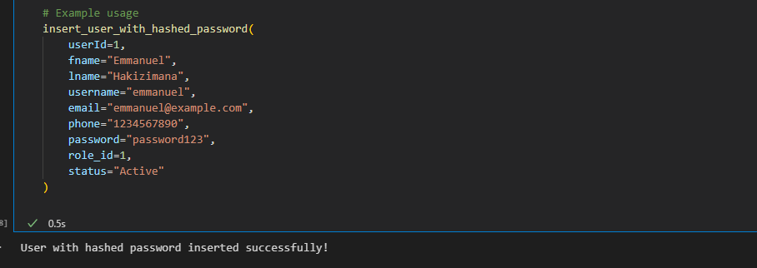

This part is necessary for secure your password as hashed method with **import bcrypt**

**5.Display users and constraint:**

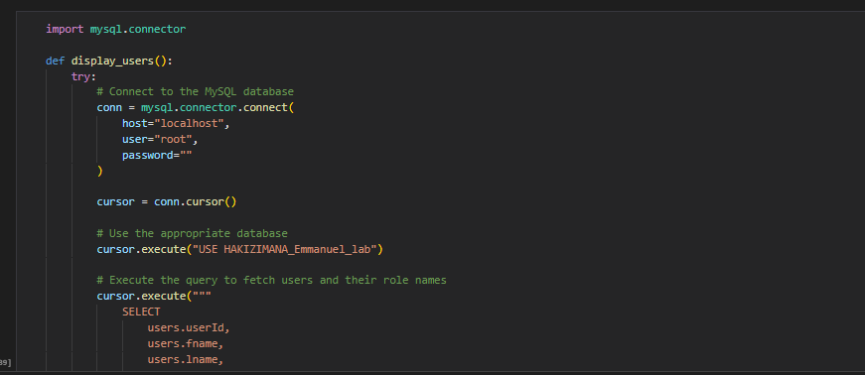

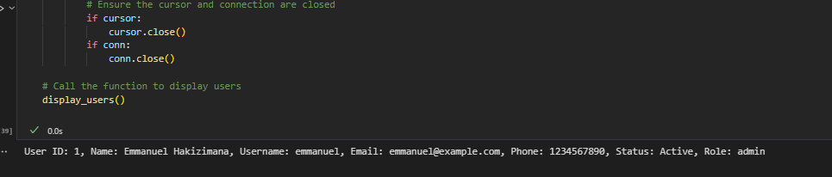

This image illustrate all users and constraint

**6.inserted into computers table:**

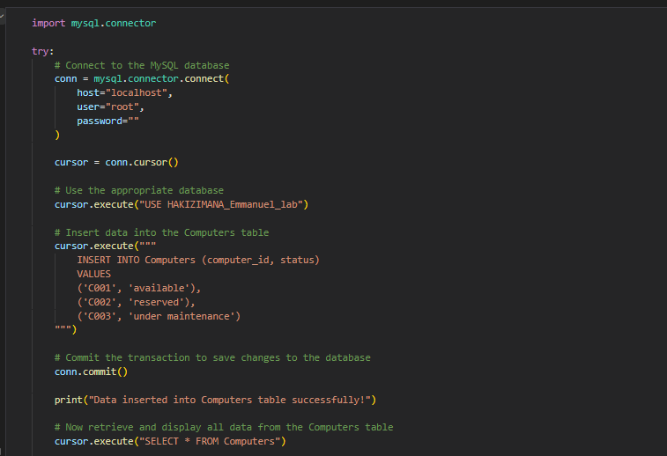

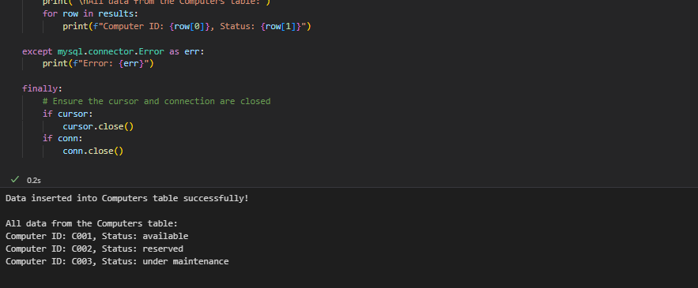

This screenshot is explained how to insert into Computer table

**7. inserted into Maintenance table:**

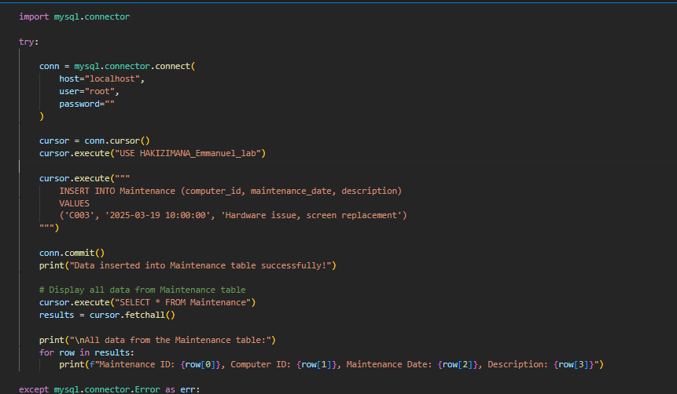

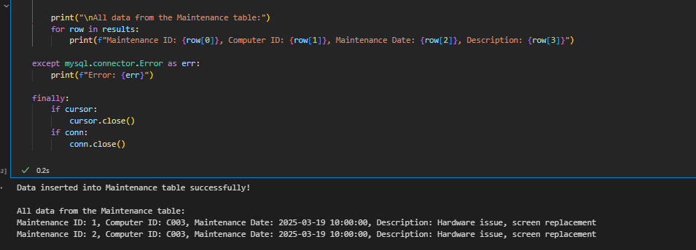

This screenshot is explained how to insert into Maintenance table

**8. update user_role:**

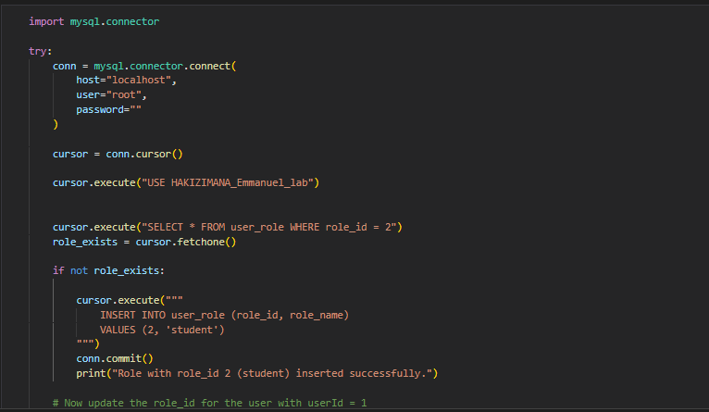

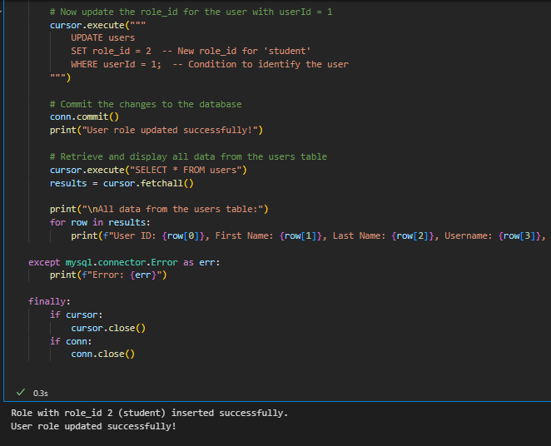

This screenshot is explained how update user_role

**9. select all users and password hashed:**

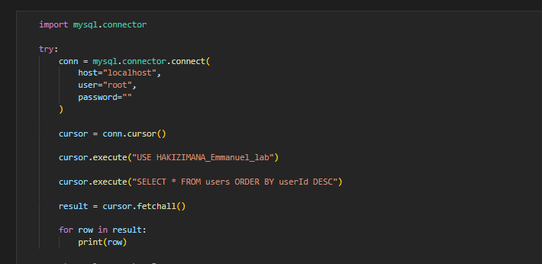

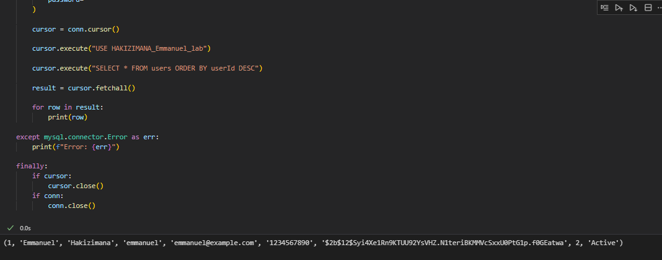

**10. join performed**

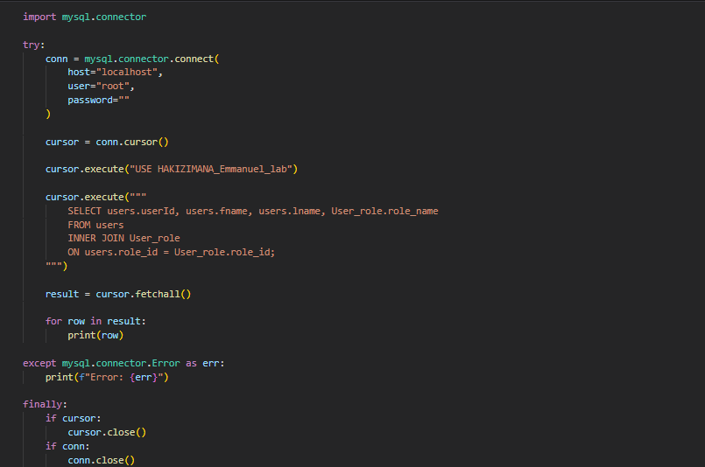

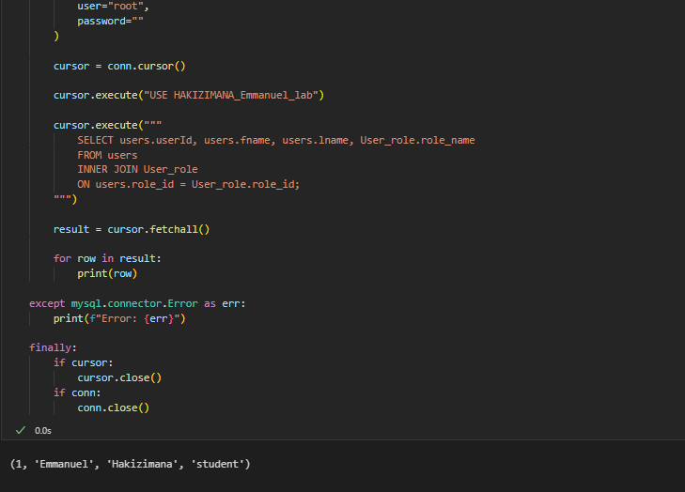

This screenshot illustrates table relationship made

12.**DEACTIVE STATUS:**

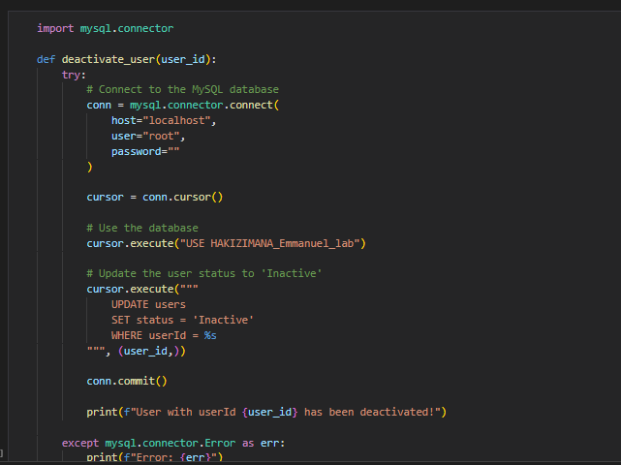

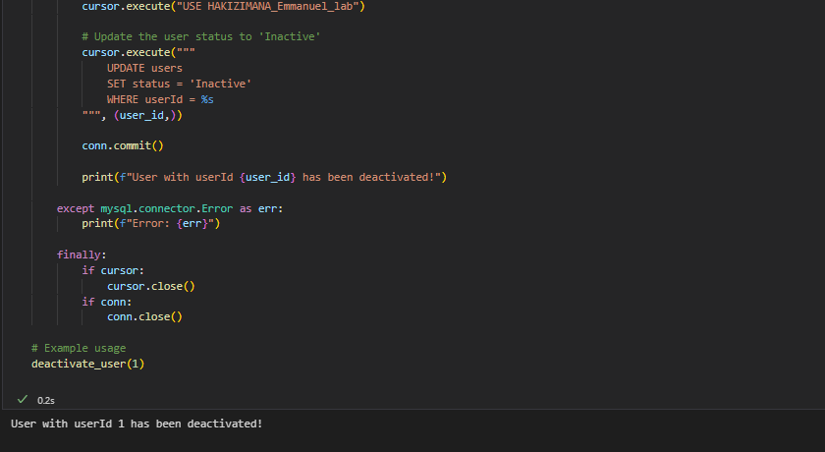

13.Update Computer table:

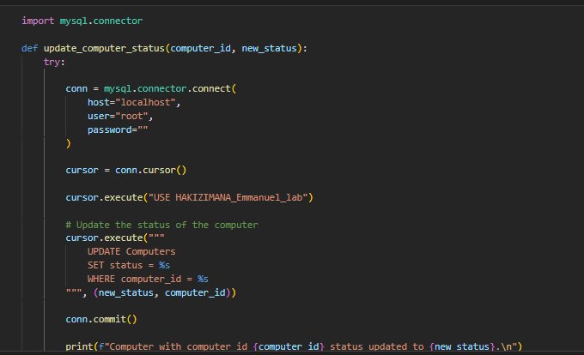

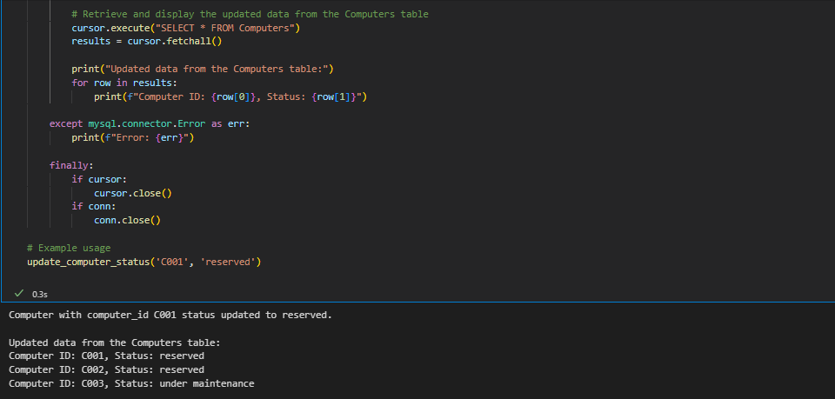

This screenshot is explain how Update Computer table and result:

**N.B: more code reference to python file save same folder**

As conclude all action is contained with ERD table:

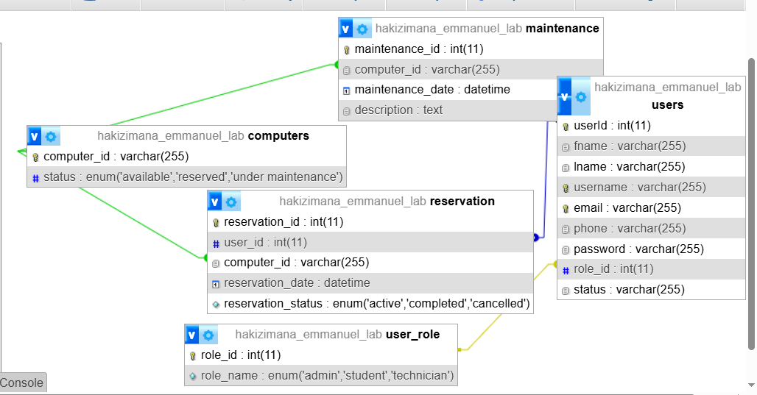

1. **Maintenance**

Stores information about computer maintenance, including the computer ID, maintenance date, and description.

1. **Computers**

Stores information about the available computers, including the computer ID and status (available, reserved, under maintenance).

1. **Reservation**

Stores information about computer reservations, including the user ID, computer ID, reservation date, and reservation status (active, completed, cancelled).

1. **User Roles**

Defines the different user roles (admin, student, technician) in the system.

1. **Users**

Stores user information, including the user ID, first name, last name, username, email, phone, role ID, and status.

**Relationships:**

* The maintenance table is linked to the computers table through the computer field.
* The reservation table is linked to the users table through the user_id field and the computers table through the computer field.
* The users table is linked to the user role table through the role_id field.